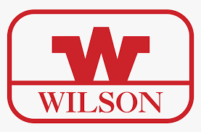

WILSON SPORTS

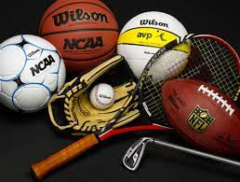

* SPECIFICATIONS

Brand : Wilson-official

Items : Football , Racket , Gloves , Hockey , etc.

DETAILS

|  |
| --- |
| The Wilson Sporting Goods Company is an American sports equipment manufacturer based in Chicago, |